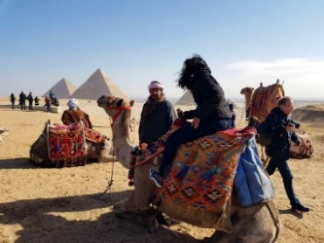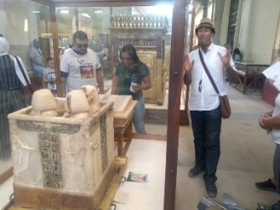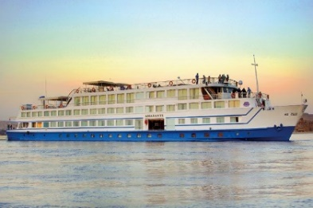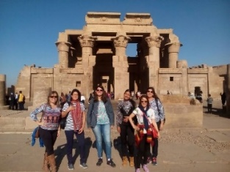

**ITINERARY**

***DAY 1: - ARRIVAL - CAIRO***

Arrival at Cairo airport, assistance and transfer to the scheduled hotel and overnight in Cairo.

***DAY 2: - PYRAMIDS & GEM***

Breakfast at the hotel and departure to visit the Giza plateau, where you will face the pyramids, the only wonder of the 7 ancient ones still standing; the great pyramid of king "Cheops" from the 27th century BC. Continue to see the other pyramids of "Queferen" and "Mikerinus". Finish the visit next to the famous enigmatic sphinx that represents the king "Queferen" himself in his form with a human head and the body of a lion. Then we continue to learn about the technique of the ancient Egyptians doing various things using the papyrus plant. Proceed to visit The Grand Egyptian Museum (GEM) in Cairo, a marvel of modern architecture and ancient history! It's right next to the iconic pyramids. The museum is set to become one of the largest and most renowned museums in the world. Return to the hotel and overnight in Cairo.

Meals: Breakfast and lunch.

**Optional tour**: Depart for the Sound & Light show in the Giza pyramids area with dinner at a local restaurant

***DAY 03 – -*** ***CAIRO – MUSEUM - MOSQUE –OLD CAIRO – KHAN EL KHALILI MARKET***

Breakfast and Departure to visit Egyptian museum of antiquities with historical and very valuable treasures especially that of the young king, the golden king “Tutankamun”, continue to visit the the fortress of Sultan Saladin and the marble mosque of Mohamed Ali. We continue towards the Coptic neighborhood to visit the important church of San Sergio, where the holy family took refuge and we end the tour in the old bazaar of KHAN EL KHALILI, Back to the hotel. In the evening, back to Go out to enjoy Dinner at a floating restaurant on the Nile with a belly dance and dervish dance show.

Meals: Breakfast, lunch and Dinner

***DAY 04- ALEXANDRIA (optional)***

Breakfast and free day in Cairo and overnight at the Hotel.

Optional Tour: Drive the road for almost 3 hours to the city of Alexandria, to enjoy and get to know this wonderful city of Alexander the Great. Visit the ancient Roman catacombs, with their 3 underground floors, then to the "Qaitbey" fortress, the same place where it was the famous Ancient Lantern of Alexandria, continue to the Library of Alexandria, the largest in the world in the shape of a solar disk. Return to Cairo, accommodation at the hotel.

Meals: - Breakfast.

***DAY 05: - CAIRO - DEPARTURE***

Breakfast and departure according to the scheduled time to Cairo airport to take the international flight home.

***RATE PER PERSON SHARING A DOUBLE OR TRIPLE ROOM***

***From 01 Oct. 2025 – 30 Apr. 2025***

|  |  |  |  |
| --- | --- | --- | --- |
| ***CATEGORIA*** | ***TOURIST*** | ***SILVER*** | ***GOLD*** |
| ***RATE PER PERSON*** | **$429** | **$589** | **$769** |
| ***SUPPLEMENT IN SINGLE ROOM*** | **$144** | **$272** | **$416** |
| ***SUPPLEMENT PEAK PERIOD*** | **$86** | **$118** | **$154** |

***PEAK PERIOD 20/12 – 07/01 & 01 – 20/04***

***SUPPLEMENT FOR A PRIVATE TOUR 250 USD PER PERSON***

***INCLUDED SERVICES***

* 04 hotel nights in Cairo in Bed & breakfast basis
* All visits mentioned in an air-conditioned car
* English-speaking guide in Cairo, Alexandria, Luxor and Aswan.
* In Hurghada or Sharm El Sheikh, if applicable, an English-speaking guide
* Entrance tickets to the mentioned sites except for any of the pyramids, the room of mummies, or the tomb of Tutankhamun, which should be purchased separately by the client directly at the point of sale.

***SERVICES NOT INCLUDED***

* Health and luggage insurance.
* Egypt Entry Visa (35 USD per person)
* Border or airport taxes
* Boarding taxes
* Entrance fees to attractions not mentioned in the itinerary.
* Mandatory tips $05 per person per day (paid upon arrival)
* Nothing not mentioned as included.
* International flights
* Drinks and other personal expenses.
* Any service not mentioned in “Services included”
* The reported price is for low season
* Gala dinner at Christmas or New Year, which is mandatory. (price up to the hotel)

***CHILDREN POLICY***

* From 0 to 01.99 year: free of charge
* From 02 to 05.99 years: Pay 25% of the adult price
* From 6 to 11.99 years: pay 50% of the adult price.
* 12 years or older is an adult
* If your package includes airline tickets, an additional fee may be charged for each accompanying child.
* The child policy applies to children sharing a room with their parents (maximum 2 children sharing a parent's room)

***CANCELLATION POLICY AND RATES:***

* Cancellations must be approved in writing.
* Unapproved cancellations will be treated as NO SHOW (100% of the price).
* Up to 31 days before arrival there is no charge to cancel.
* Less than 30 days to 15 days before arrival, 50% of the purchased package is charged.
* Less than 15 days will be charged as NO SHOW (100% of the price).

***PLANNED OR SIMILAR HOTELS***

|  |  |  |  |
| --- | --- | --- | --- |
| CIUDAD/CAT | TOURIST | SILVER | GOLD |
| CAIRO | STAY INN PYRAMIDS | [PYRAMIDS PARK RESORT](https://pyramidsparkresort.com/) | [CONRAD CAIRO HOTEL](https://www.hilton.com/en/hotels/caicici-conrad-cairo/) |
| CLEOPATRA ARACAN HOTEL | [PYRAMIDS RESORT BY JAZ](http://www.oasis.com.eg/?fbclid=IwAR31ok5B2TDocJ8uCe6PyxVbRFaOnJ7D-aTvGlVlWR7N2dDwaE0v6BtiAUg) | [HILTON GRAND NILE TOWERS](https://www.hilton.com/en/hotels/caignhi-cairo-grand-nile/) |
| [AZAL PYRAMIDS HOTEL](https://azalpyramids.com/) | [RAMSES HILTON HOTEL](https://www.hilton.com/en/hotels/cairhtw-ramses-hilton/) | [STEIGENBERGER PYRAMIDS](https://www.facebook.com/GratsiaTours/videos/858157581662105) |

Observations

* Requires a valid passport for no less than 6 months from the date of return from this trip;
* Air tickets, when included in the itinerary, issued with restrictions and cannot be refunded.
* Flights from Cairo to Aswan and Luxor depart very early in the morning. For this reason, that day breakfast will be box.
* Hotel accommodation generally follows international time criteria.
* Air tickets, when included in the itinerary, are issued with restricted promotional fares. Always check the baggage allowance.
* Prices subject to change without prior notice and seat availability.
* Breakfast included in the itineraries follows the schedules established by the hotels. If you need to leave the hotel before this service begins, it will not be provided and there will be no refund.
* For operational reasons, the order of the tours may change without prior notice.
* Expected hotels are subject to possible variations to similar hotels at any time without prior notice.
* This itinerary generally done in groups, made up of passengers of various nationalities. In the event that there are no other passengers on the requested date, the excursion will depart in the same way, individually or in small groups, which may consist of different people each day.
* Connection or transfer costs to airports due to delay or loss of luggage (loss of luggage is the sole responsibility of the airline and any additional costs resulting from the loss will be charged separately and a receipt will be issued so that the passenger can be compensated with insurance company)
* Check Early or Check Later (check in starts at 3:00 pm on the day of arrival and check out at 12:00 pm on the last day). There will be an additional charge for the early arrival flights if a passenger wishes to check in or out of the room early.
* Prices are subject to change based on the ticket price of the visited sites or any increase in the price of gasoline.
* Private guide means, guide in your chosen language and can be with a small number of people during the tours.
* Peak period during Christmas & new year (12/20 – 01/10) & Easter (20/03-10/04)